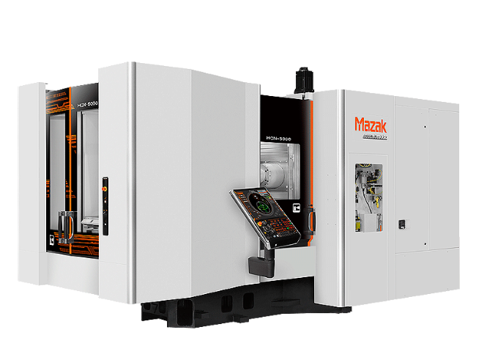

2022 – Mazak HCN 5000

Horizontal Machining Centre

Capacity Pallet Size 19.690 in / 500 mm

Maximum Workpiece Height 39.370 in / 1000 mm

Spindle Spindle Taper Big Plus CAT 40

Maximum Speed 18000 rpm

Magazine Number of Tools 160

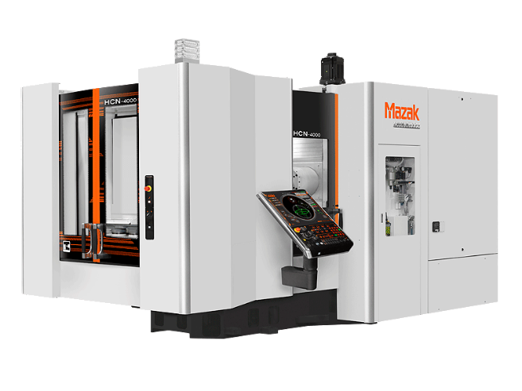

2015 – Mazak Nexus 4000

**Model: HCN 4000**

**Pallet Size:** 15.75” x Max. Height: 35.43”

Spindle Taper No 40,

Maximum Speed 18,000 rpm

No. of Tools: 80

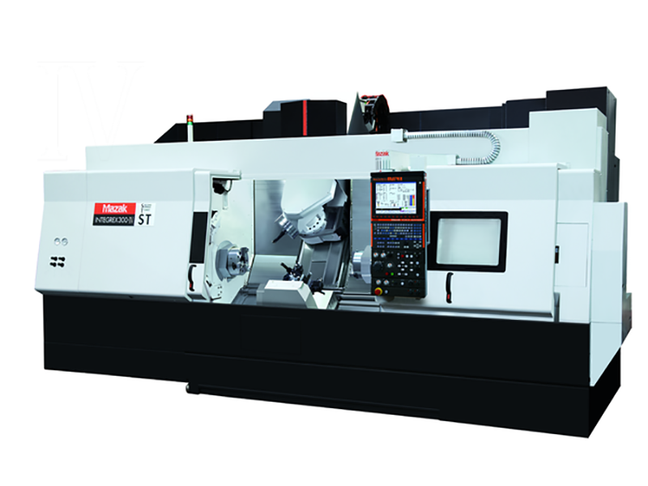

2008 - Mazak – Integrex

**Model: 300-4ST** 7-axis Lathe

40 tool magazine with automatic tool length measure

12” chuck main spindle, 10” chuck sub spindle

9 station sub turret, 60” maximum length,

24” maximum cutting diameter Full 5-axis capability

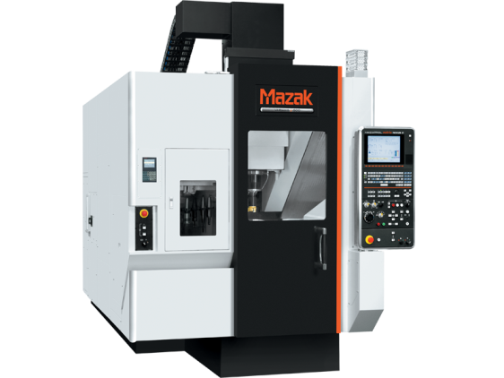

2014 - Mazak – Variaxis 500 – 5X – 2 Pallet

**Model: J-500 II** 5 – axis Vertical Milling

18,000 RPM spindle (big plus) with coolant through,

30 tool magazine with automatic tool length measure

20” working diameter

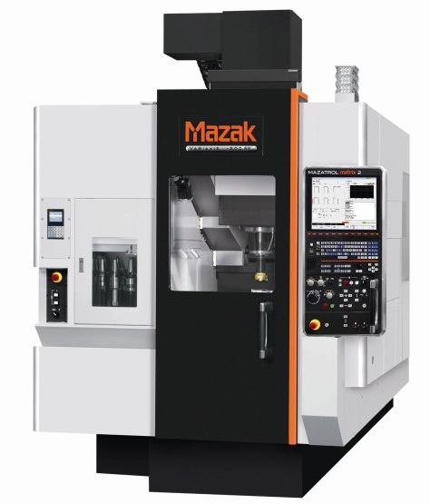

2015 - Mazak – Variaxis 500 – 5X - single pallet

**Model: J-500 -** 5 – axis Vertical Milling

18,000 RPM spindle (big plus) with coolant through,

30 tool magazine with automatic tool length measure

20” working diameter

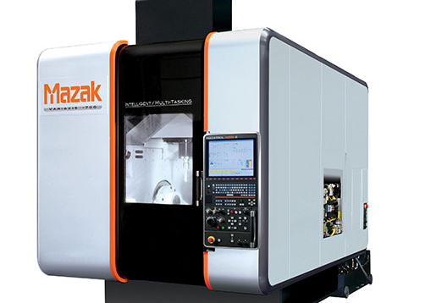

2014 - Mazak – Variaxis I-700

**Model: VRX I-700 -** 5-axis Vertical Milling

18,000 RPM spindle (big plus) with coolant through

40 tool magazine with automatic tool measure

33” working diameter

Maximum table load - 700 kg

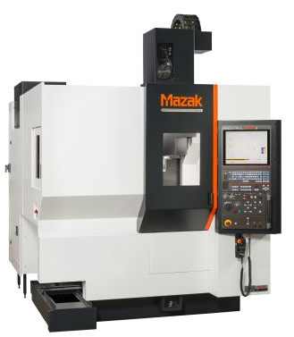

2013 - Mazak - Vertical Center Universal 400A 5X

**Model : VCU 400 5X -** 5 – axis Vertical Milling

12,000 RPM Spindle

30 tool magazine with automatic tool length measure

16” working diameter

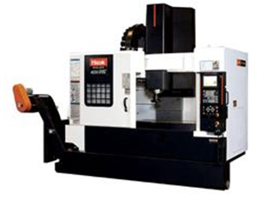

2009 - Mazak – Vertical Centre Nexus

**Model: VCN 510C II - with** 4-axis

Extended table = 54” x 20”

30 tool magazine with automatic tool length measure

Full force 4-axis capabilities

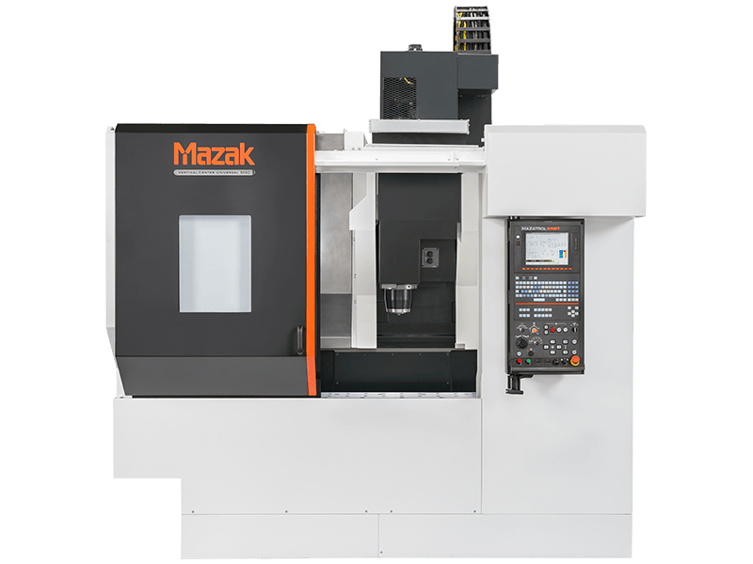

2014 - Mazak – Vertical Universal Milling Centre

**Model: VCU 500 C -** 4-axis Vertical Milling

Extended Table = 40” x 20”

30 tool magazine with automatic tool length measure

Full force 4-axis capabilities

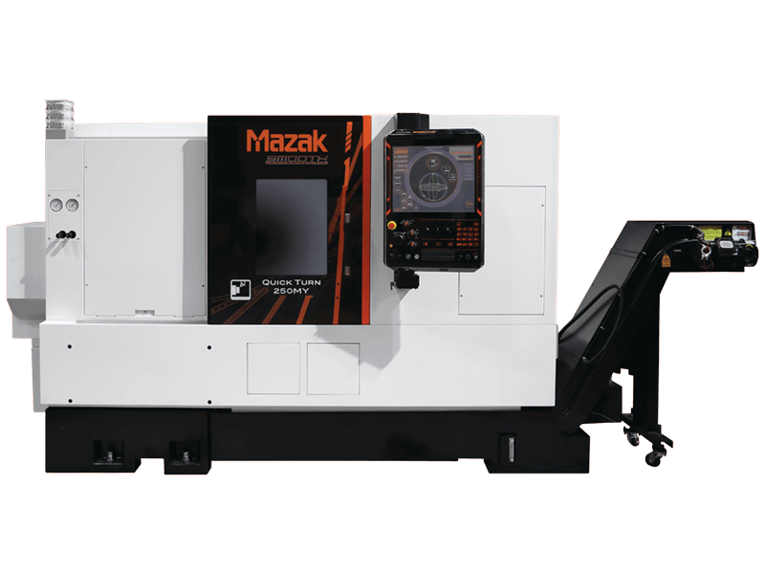

2020 - Mazak Quick turn 250MY , 40”/1000U KY Mazatrol Smoothing Control. **Model: QT 250MYE** 10” chuck

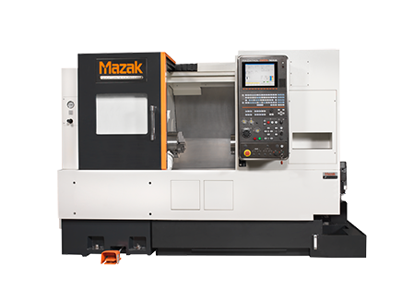

2008 - Mazak – Nexus Turning Milling Machine

**Model: QTN 250 MY**  - 4-axis Lathe

10” chuck, 16” swing, 20” between centre

12 station turret with live tools

Automatic tool length measurement



2008 - Mazak – Vertical Centre Nexus

**Model: VCN 510C II - 3**-axis Vertical Milling

Extended table = 54” x 20”

30 tool magazine with automatic tool length measure

12,000 RPM Coolant through spindle

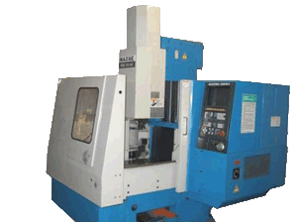

Mazak - Milling Machine – YR - 1989

**Model: VQC-15/40** - 3 axis Vertical Milling

Table size: 20” x 16”

6,000 RPM

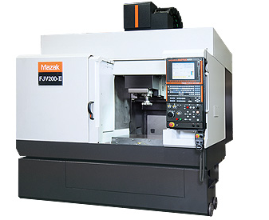Mazak - Vertical Milling Machine – YR - 1999

**Model: FJV 200 -** 3 axis Milling Machine

Table Size: 30” x 20”, 30 tool magazine

12,000 RPM Spindle

And

**Model: FJV 250**

Table Size: 20” x 40”, 42 tool magazine

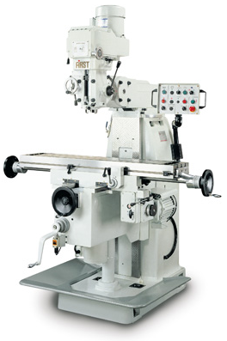

2003 - First Vertical Milling Machine

**Model: LC-20 VSG** - 3 axis

42” x 12” travel with digital readout and power feed

OTHER:

Mazak – 2 Axis Lathe

**Model: QT20 -** 2 axis Turning Centre

20” between centres, 12 station tool turret with automatic offset measure

10” chuck, 5,000 RPM

First - Milling Machine

**Model: LC-1-1/2 VS**

30” x 10” travel with digital readout and power feed

Morton - Manual Lathe

**Model: FEL-1340G**

8” chuck , 2” through spindle

Hardinge - Manual Lathe, 2-axis

**Model: HLV H869**

Sunnen Honing Machine

**QUALITY CONTROL:**

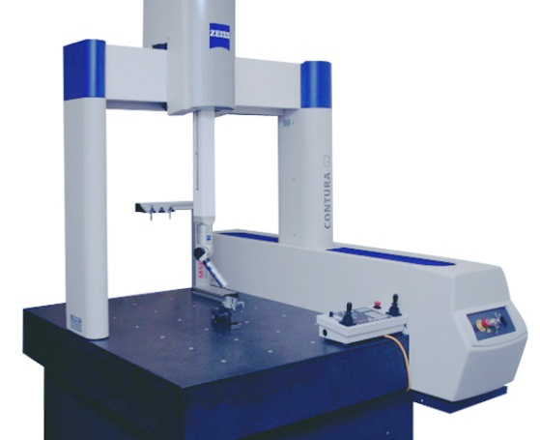

2013 Coordinate Measuring Machine

**Model:** Zeiss Contura G2

Comes with 22” LCD Monitor

Measuring range: X = 700 mm, Y = 1,000 mm, Z = 600 mm

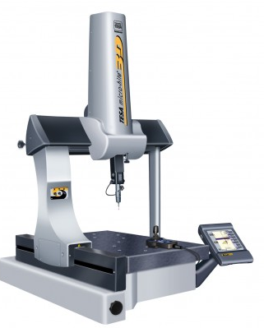

2006 – 3D – Tesastar CMM

Measuring Range: X = 440mm, Y = 490 mm, Z = 390mm

Measuring speed = 13.62 in/sec.

Max part weight = 501 lbs